

23CSIS10P

Introduction to Information Systems

# Phase 2 Report

# Hotel data base

# Project Description:

We want to create a database to store data about a hotel. For each guest, it’s important to know his social security number, name, date of birth, phone number, gender, email, room type, room code, payment number along with his check-in and check-out dates. These information is gathered by the receptionist. Each receptionist has a unique ID, a name, date of birth, salary, gender and building ID. The reservation made by the guest has a unique number, a booking date, arrival date, departure date, room type and price, guest ID, guest’s email, guest’s phone number and guest’s social security number. Each room in the hotel has a unique code, type, price per night, location, capacity, building ID and availability. Each housekeeper of the rooms has a social security number, gender, contact information, salary and number of working hours. The hotel consists of many buildings, there is a unique building ID, location, number of floors, type and manager for each building. The hotel also has many facilities. For each one, there is a unique facility type, opening and closing times, restrictions and location. Each event organized by the hotel has a unique name, type, organizer, start and end dates, building ID and hall number. Each hall has a unique number, type, availability, capacity and Building ID. Also, Maintenance staff each has a unique social security number, a name, date of birth, address, contact information, salary, renovation type and building ID. Each manager of the hotel has a unique social security number, a name, date of birth, address, job description, area of responsibility, contact information, number of experience years and building ID. Before the departure of the guest, a bill is paid. Each bill has a unique number, a method, date, amount, reservation number and the guest’s social security number.

# Entity Relationship Diagram:

N

M

Facility

N

M

Maintenance

1

1

Manager

M

1

Event

M

1

M

1

Hall

Receptionist

1

M

N

M

Housekeeper

Building

Room

M

1

M

1

Reservation

1

1

Bill

Guest

# Tables and Attributes:

|  |  |
| --- | --- |
| Bill | |
| Bill_Number(PK) | Number |
| Bill_Method | Short Text |
| Bill_Date | Date/Time |
| Bill_Amount | Currency |
| Guest_SSN(FK) | Number |
| Reservation_Number(FK) | Number |

|  |  |
| --- | --- |
| Building | |
| Building_ID(PK) | Number |
| Building_Name | Short Text |
| Building_Number_Of_Floors | Number |
| Building_Type | Short Text |
| Building_Manager_Code | Short Text |
| Building_Facility | Short Text |
| Manager_SSN(FK) | Number |

|  |  |
| --- | --- |
| Cleans | |
| Room_Code(PK) | Number |
| Housekeeper_SSN(PK) | Number |
| Cleaning_Day | Date/Time |

|  |  |
| --- | --- |
| Event | |
| Event_Number(PK) | Number |
| Event_Type | Short Text |
| Event_Organizor | Short Text |
| Event_Begining_Date | Date/Time |
| Event_End_Date | Date/Time |
| Event_Building_ID(FK) | Number |
| Hall_Number(FK) | Number |

|  |  |
| --- | --- |
| Facility | |
| Facility_Code(PK) | Short Text |
| Facility_Open_Time | Short Text |
| Facility_Close_Time | Short Text |
| Facility_Location | Short Text |
| Facility_Type | Short Text |

|  |  |
| --- | --- |
| Fixing | |
| Maintenance_ID(PK) | Number |
| Facility_Code(PK) | Short Text |
| Maintenance_Time | Date/Time |
| Facility_Location | Short Text |

|  |  |
| --- | --- |
| Guest | |
| Guest_SSN(PK) | Number |
| Guest_Full_Name | Short Text |
| Guest_Room_Number | Number |
| Guest_DOB | Date/Time |
| Guest_Phone_Number | Number |
| Guest_Checkin_Date | Date/Time |
| Guest_Checkout_Date | Date/Time |
| Guest_Gender | Short Text |
| Guest_Email | Short Text |

|  |  |
| --- | --- |
| Hall | |
| Hall_Number(PK) | Number |
| Hall_Type | Short Text |
| Hall_Availability | Yes/No |
| Hall_Capacity | Number |
| Building_ID(FK) | Number |

|  |  |
| --- | --- |
| Housekeeper | |
| Housekeeper_SSN(PK) | Number |
| Housekeeper_Gender | Short Text |
| Housekeeper_Contact_Info | Number |
| Housekeeper_Salary | Currency |
| Housekeeper_Working_Hours | Number |
| City | Short Text |

|  |  |
| --- | --- |
| MaintenanceOfBuildings | |
| Maintenance_ID(PK) | Number |
| Building_ID(PK) | Number |
| Issue | Short Text |

|  |  |
| --- | --- |
| Maintenance | |
| Maintenance_ID(PK) | Number |
| Maintenance_Start_Date | Date/Time |
| Maintenance_End_Date | Date/Time |
| Maintenance_Renovation_Type | Short Text |
| Maintenance_Building_ID(FK) | Number |
| Maintenance_Status | Short Text |
| Last_Maintenance | Date/Time |

|  |  |
| --- | --- |
| Manager | |
| Manager_SSN(PK) | Number |
| Manager_Name | Short Text |
| Manager_DOB | Date/Time |
| Manager_Address | Short Text |
| Job_Description | Short Text |
| Manager_Years_Of_Experience | Number |
| Manager_Mail | Long Text |
| Manager_Building_Code | Short Text |

|  |  |
| --- | --- |
| Receptionist | |
| Rec_ID(PK) | Number |
| Rec_First_Name | Short Text |
| Rec_Mid_Name | Short Text |
| Rec_Last_Name | Short Text |
| Rec_DOB | Date/Time |
| Rec_Salary | Currency |
| Rec_Gender | Short Text |
| Rec_Building_ID(FK) | Number |

|  |  |
| --- | --- |
| Reservation | |
| Res_number(PK) | Number |
| Res_booking_date | Date/Time |
| Res_arrival_date | Date/Time |
| Res_departure_date | Date/Time |
| Room_type | Short Text |
| Room_price | Currency |
| Guest_ID | Number |
| Guest_Email(FK) | Hyperlink |
| Guest_Phone_Number(FK) | Number |
| Guest_SSN(FK) | Number |

|  |  |
| --- | --- |
| Room | |
| Room_Num(PK) | Number |
| Room_Price_per_Night | Currency |
| Room_Type | Short Text |
| Room Availability | Short Text |
| Room_floor | Short Text |
| Room_Capacity | Number |
| Room_Building_ID(FK) | Number |
| Res_number(FK) | Number |

# Database Schema (Clear Screenshot from Microsoft Access):

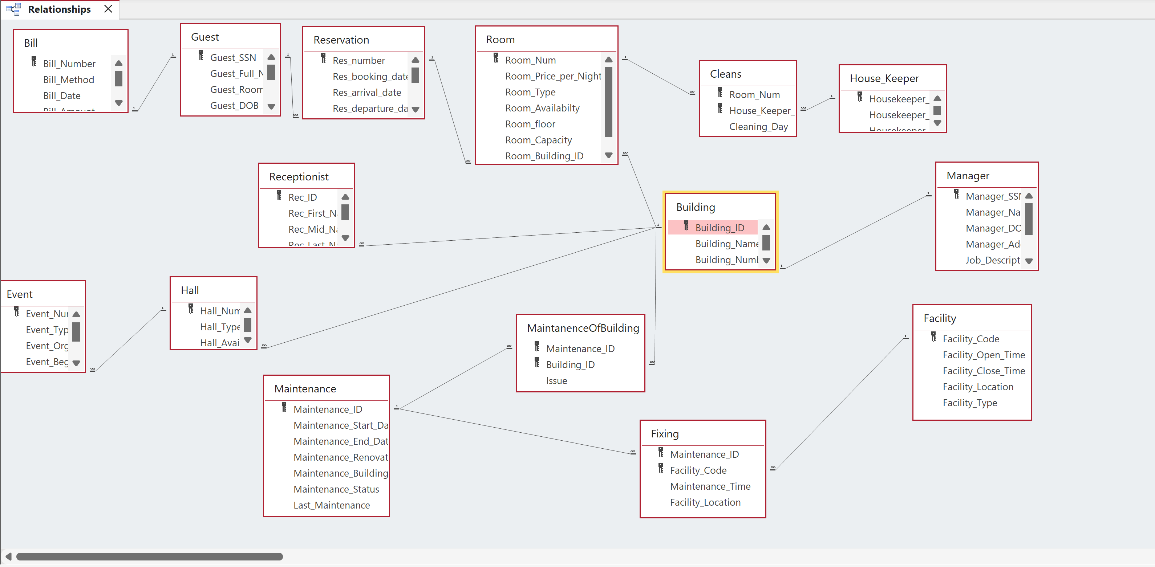

# Application Form 1:

EVENT INFORMATION FORM:

# Description of Output:

This form inputs information about every new event in the event table.

# Application Form 2:

MANAGER INFORMATION FORM:

# Description of Output:

This form inputs the information of each manager.

# Application Form 3:

HOUSEKEEPER_DATA FORM:

# Description of Output:

A sub_form that would assign courses to the newly added housekeeper members.

# Application Form 4:

Maintenance Form:

# Description of Output:

A Sub_form to assign the data of maintenance.

# Application Form 5:

Payment Information Form:

# Description of Output:

This form inputs the payment information of a new guest in the Bill table.

# Application Form 6:

Guest Information Form:

# Description of Output:

This form inputs the information of a new guest in the Guest table.

# Application Form 7:

Room Form:

# Description of Output:

The room form is to help the staff to check the rooms and to change them.

# Application Form 8:

Building Form:

# Description of Output:

The building form helps the staff to check the buildings and to check every manager responsible for that building and to change in it.

# Application Form 9:

Receptionist Form:

# Description of Output:

This form is to add new receptionists or view data about specific receptionist.

# Application Form 10:

Reservation Form:

# Description of Output:

This form is to add new reservation or cancel a reservation.

# Application Form 11:

Hall Form:

# Description of Output:

# Application Form 12:

Facility Form:

# Description of Output:

# Report 1:

# Description of Output:

This report displays all the details of each event and gives you the option to go to the event date information directly.

# Report 2:

EVENT DATE INFORMATION REPORT

# Description of Output:

This report displays the start date and end date of each event between 12/1/2023 to 12/30/2023 and their hall numbers and the event type. (from event date information query)

# Report 3:

MAINTENANCE REPORT:

# Description of Output:

A report that shows maintenance data.

# Report 4:

NUMBER_OF_HOUSEKEEPER_GENDER_IN_EACH_CITY:

# Description of Output:

A report that shows how many housekeepers female and male in each city.

# Report 5:

Guests with more than $3000 bill amount:

# Description of Output:

This report displays the guests, identified by the SSN, with more than $3000 bill amount.

# Report 6:

Bill Information Report:

# Description of Output:

This report displays the bill information of each guest.

# Report 7:

Receptionists’ salaries report:

# Description of Output:

This report is to show data about receptionists' salaries.

# Report 8:

Reservation Report:

# Description of Output:

This report is to show all data about all reservations.

# Report 9:

Building Report:

# Description of Output:

The building report shows a report of every building and status only.

# Report 10:

Available Room Report:

# Description of Output:

The available room report helps allow the guest to check the empty rooms and to do the reserving form and reserve a room.

# Report 11:

Facility Report:

# Description of Output:

# Report 12:

Available_Halls Report:

# Description of Output:

# Query 1:

**Event_Date_Information:**

# Description of Output:

Retrieve all events between 12/1/2023 to 12/30/2023 by order and write their type and their hall number.

# Query 2:

**Manager_Data:**

# Description of Output:

Retrieve all information about each manager as their name, address, building code, and job description.

# Query 3:

**Number_Of_Each_Building:**

# Description of Output:

Retrieve the number of each building type.

# Query 4:

**Ascendingly ordered bill amount:**

# Description of Output:

Retrieve the bill amount of each guest, identified by his SSN, in ascending order along with the payment method.

# Query 5:

**Guests in 2021:**

# Description of Output:

Retrieve the guests who visited the hotel in 2021.

# Query 6:

**Guests with more than $3000 bill amount:**

# Description of Output:

This query retrieves the guests, identified by SSN, who have paid more than $3000.

# Query 7:

**Maintenance_Start_Date_Between_3/1/2024_And_10/1/2024:**

# Description of Output:

Retrieve Maintenance_Start_Date between 3/1/2024 and 10/1/2024.

# Query 8:

**Similar_Salary:**

# Description of Output:

Retrieve how many housekeepers have the same salary (only if they are more than 1 housekeeper).

# Query 9:

**HowManyFemaleAndMaleInEachCity:**

# Description of Output:

Retrieve in housekeeper how many females and males in each city.

# Query 10:

**Average_And_Maximum_And_Minimum_Price_Of_Room:**

# Description of Output:

Retrieve the average, maximum, and minimum prices of the rooms per night.

# Query 11:

**Empty_Rooms:**

# Description of Output:

Get every available room.

# Query 12:

**Number_Of_Room_Per_Price:**

# Description of Output:

Show the number of rooms with similar prices.

# Query 13:

**receptionists’ salaries:**

# Description of Output:

This query is to retrieve the receptionist ID

, first name, last name , and salary

The salary is ordered descendingly

# Query 14:

**receptionists’ salary info:**

# Description of Output:

This query is to retrieve the average, minimum, and maximum salary earned by receptionists.

# Query 15:

**single rooms reservations info:**

# Description of Output:

This query is to retrieve data about all single rooms reserved.

# Query 16:

**double rooms reservations:**

# Description of Output:

This query is to retrieve data about all double rooms reserved.

# Query 17:

**trible rooms reservations:**

# Description of Output:

This query is to retrieve data about all trible rooms reserved.